1. **Question:** Which of the following is true about Java interfaces?

a) Interfaces can contain concrete methods.

b) Interfaces can have instance variables.

c) A class can implement multiple interfaces.

d) Interfaces can be instantiated directly.

- **Answer Key:** c) A class can implement multiple interfaces.

- **Explanation:** Java allows a class to implement multiple interfaces, providing a way to achieve multiple inheritance.

2. **Question:** Which keyword is used to define an interface in Java?

a) "class"

b) "interface"

c) "implements"

d) "extends"

- **Answer Key:** b) "interface"

- **Explanation:** The "interface" keyword is used to define an interface in Java.

3. **Question:** True or False: All methods in an interface are implicitly public and abstract.

- **Answer Key:** True

- **Explanation:** By default, all methods in an interface are public and abstract unless declared otherwise.

4. **Question:** Fill in the blank: In Java, a class uses the __________ keyword to implement an interface.

- **Answer Key:** implements

- **Explanation:** The "implements" keyword is used by a class to implement an interface.

5. **Question:** Which of the following can an interface in Java not have?

a) Abstract methods

b) Default methods

c) Static methods

d) Private constructors

- **Answer Key:** d) Private constructors

- **Explanation:** Interfaces cannot have constructors because they cannot be instantiated.

6. **Question:** Which of the following is the parent class of all exception classes in Java?

a) "Error"

b) "RuntimeException"

c) "Throwable"

d) "Exception"

- **Answer Key:** c) "Throwable"

- **Explanation:** The "Throwable" class is the superclass of all exceptions and errors.

7. **Question:** What happens when an exception is not caught in Java?

a) The program continues execution normally.

b) The program terminates.

c) The program ignores the exception.

d) The exception is thrown again and again.

- **Answer Key:** b) The program terminates.

- **Explanation:** If an exception is not caught, the program will terminate, and the stack trace will be printed.

8. **Question:** Fill in the blank: In Java, the "try" block must be followed by either a "__________" block or a "finally" block.

- **Answer Key:** catch

- **Explanation:** A "try" block must be followed by at least one "catch" block or a "finally" block.

9. **Question:** Which of the following statements about the "finally" block is true?

a) It is executed only when an exception occurs.

b) It is executed only when an exception does not occur.

c) It is executed regardless of whether an exception occurs or not.

d) It is not mandatory to include a "finally" block in exception handling.

- **Answer Key:** c) It is executed regardless of whether an exception occurs or not.

- **Explanation:** The "finally" block is always executed after the "try" and "catch" blocks, regardless of whether an exception occurs.

10. **Question:** True or False: You can have multiple "catch" blocks to handle different types of exceptions in a single "try" block.

- **Answer Key:** True

- **Explanation:** Multiple "catch" blocks can be used to handle different types of exceptions that may be thrown by a "try" block.

11. **Question:** Which of the following exceptions is a checked exception in Java?

a) "NullPointerException"

b) "ArrayIndexOutOfBoundsException"

c) "IOException"

d) "ArithmeticException"

- **Answer Key:** c) "IOException"

- **Explanation:** "IOException" is a checked exception, which means it must be either caught or declared in the method's "throws" clause.

12. **Question:** Fill in the blank: The "throws" keyword in a method declaration indicates that the method may throw a __________.

- **Answer Key:** Exception

- **Explanation:** The "throws" keyword is used in a method declaration to specify which exceptions can be thrown by the method.

### Additional Challenging Java Problem Set: Interfaces, Exceptions, and Exception Handling

#### Interfaces

13. **Question:** Which of the following statements about multiple inheritance in Java is true?

a) A class can extend multiple classes.

b) A class can implement multiple interfaces.

c) An interface can extend multiple classes.

d) An interface can implement another interface.

- **Answer Key:** b) A class can implement multiple interfaces.

- **Explanation:** Java allows a class to implement multiple interfaces, providing a way to achieve multiple inheritance of type.

14. **Question:** Given the following interface and class definitions, what will be the output when "new Test().methodB()" is called?

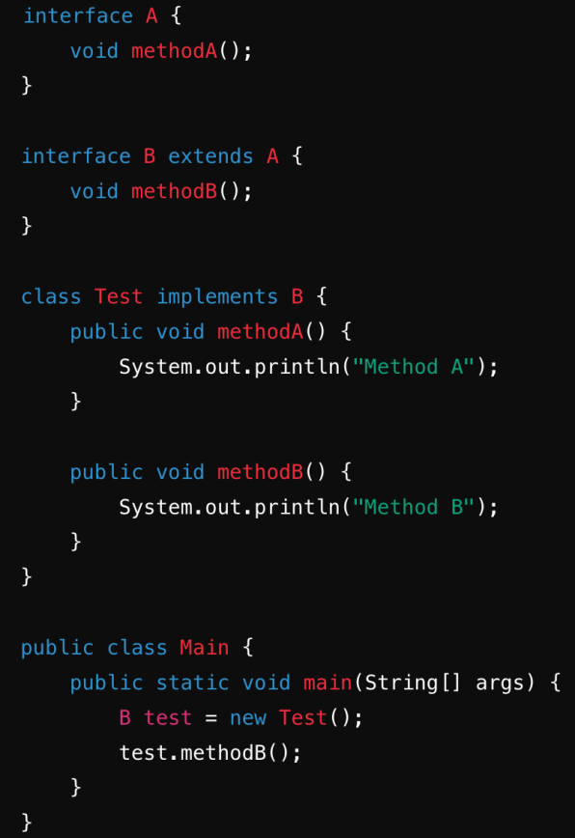

a) Method A

b) Method B

c) Compilation error

d) Runtime error

- **Answer Key:** b) Method B

- **Explanation:** The "Test" class implements both "methodA()" and "methodB()". When "methodB()" is called, "Method B" is printed.

15. **Question:** In the following code, what exception will be thrown and at which line?

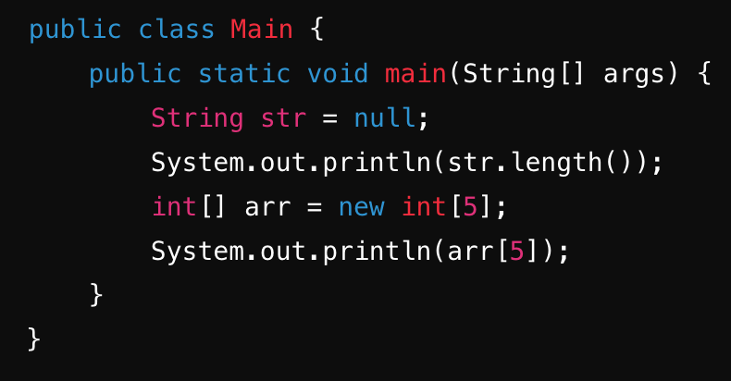

a) "NullPointerException" at line 3

b) "ArrayIndexOutOfBoundsException" at line 5

c) "NullPointerException" at line 2

d) "ArrayIndexOutOfBoundsException" at line 3

- **Answer Key:** a) "NullPointerException" at line 3

- **Explanation:** Attempting to call "length()" on a null string throws a "NullPointerException" at line 3.